**Biomedical Technology Services**

BIR general x-ray shielding calculation tool

# Purpose:

To calculate shielding requirements for a general x-ray room based on an exi log

# Requirements:

* Exi log from device
  + Must be of a type recognised by the script. Currently this includes:
    - Siemens Ysio
* Room floor plan
* Software:
  + ImageJ/FIJI (FIJI is better for large floor plan files)
  + Local python installation or NAS access
    - For local installation, the packages required are: pandas, numpy, matplotlib, shapely, geos, descartes, pdf2image, glob
    - Alternatively, copy the winpy folder (a small python distribution) from the nas drive to c:\ \\10.80.8.91\bts-nas\BTS-Herston-MedPhys\MedPhys\BTS Central\Other\Shielding\
  + Set of python scripts
    - Y:\BTS-Herston-MedPhys\MedPhys\BTS Central\Other\Shielding\parse_exi
    - <https://github.com/ckswilliams/parse_exi>

# Workflow overview:

1. Obtain EXI log and room floor plan
2. Use ImageJ to measure room geometry, save the geometry to csv files
3. Open EXI log and room geometry inputs using exi_parse script
4. Generate reports
5. Optional: Use generated XRAYBARR files to perform dose calculations with XRAYBARR

# Step-by-step usage guide

1. Make a copy of the input_sources.csv, input_rooms.csv, and put them in a directory with the exi_log (not strictly required, but grouping the files is convenient)
2. Make the floor plan available in an image format
   1. The script pdftoimg can be used for this purpose, it breaks apart a pdf file into an image corresponding to each page
3. Open the image in ImageJ
4. Set the scale of the image in ImageJ
   1. Use the line selector to select a feature of known size
   2. Open Analyse -> Set scale
   3. Input the size of the known feature, in m
   4. Activate the Global checkbox
5. If the floorplan contains multiple x-ray rooms, select the region around one and duplicate it (ctrl–shift-d)
6. 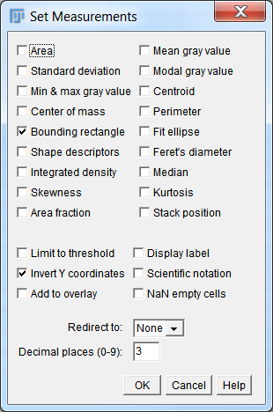Open Analyse -> Set measurements. Change the settings so that only the Bounding rectangle and inverted Y coordinate checkboxes are selected
7. Open the copy of ‘input_rooms.csv’. For each radiation sensitive room around the x-ray room in the floor plan:
   1. Record the name of the room in the input_rooms.csv file NO REPEATED ROOM NAMES, DO NOT INCLUDE THE X-RAY ROOM ITSELF
   2. Select the rectangle tool. For each nearby room, click and drag the rectangle tool to cover the internal wall.
   3. 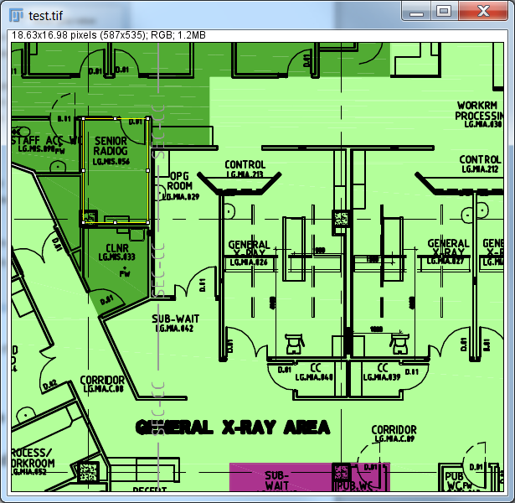Save the measurement with ctrl-m
   4. Repeat for each radiation sensitive room
8. Copy BX, BY, Width, Height into the similar columns in the input_rooms.csv file
9. Open the ‘input_sources.csv’ text file
   1. 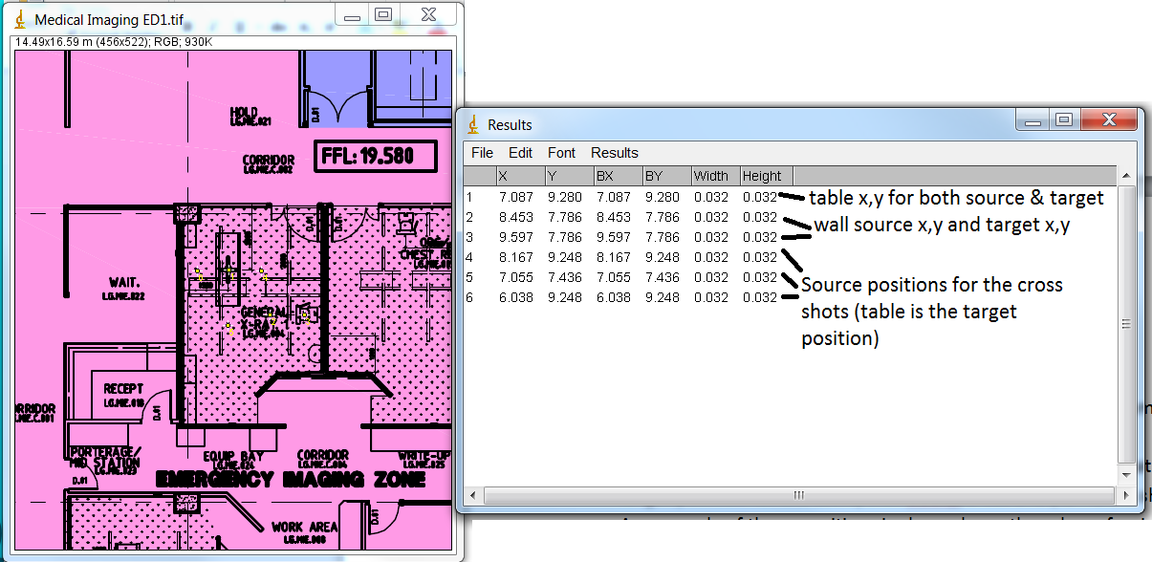Either use the multipoint tool or cursor to determine the location of each source and target position for the table, wall bucky, cross shot, 2nd cross shot and 3rd cross shot. An example of these positions is shown here, though professional judgement will be required
   2. Input these values into the ‘input_sources.csv’ text file
10. To allow the script to create a pretty overlaid image, save the room image in .tif format (probably into the same directory as the input files in order to keep things tidy)
11. Open the script gui using either the run_interface - network.bat file (slow), or using your local copy of python (if winpy is copied to c:\winpy, the run_interface.bat file will work)
12. 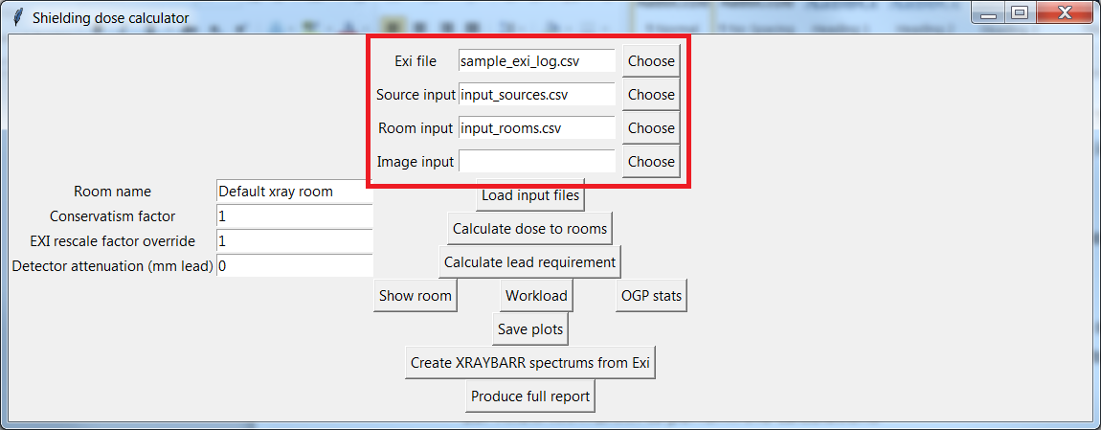Select the exi file, input_sources and input_rooms files using the menus
13. Click Load input files
    1. If the loading failed, make sure the files were properly selected
    2. Ensure the exi log is from a type of device mentioned at the beginning of this document
    3. Ensure the column headings and data types of the input files are similar to those in the sample files
    4. If all these fail, contact me and I will attempt to troubleshoot
14. 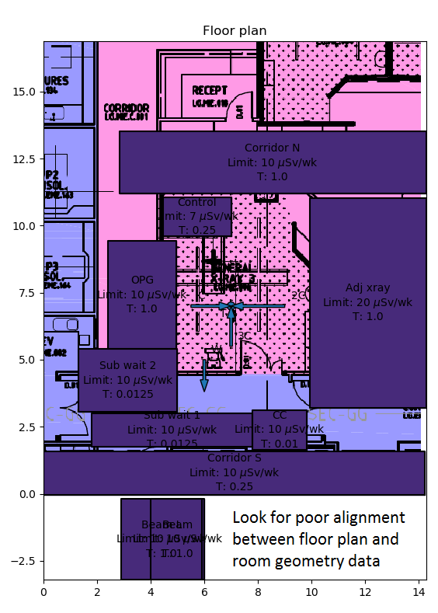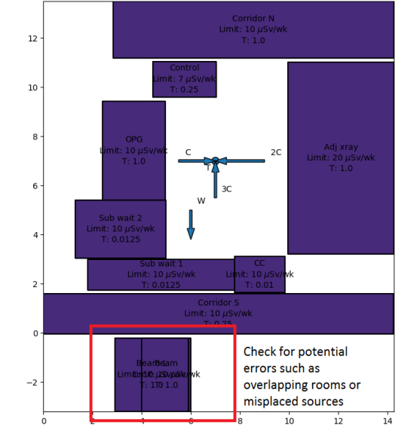Use the show room, Workload, and OGP stats buttons to generate plots in order to sanity check the input files. Use best judgement to evaluate whether the resulting plots appear reasonable
15. Adjust the manual conservatism, detector attenuation and exi rescale factors if desired. These allow the user to adjust the level of conservatism assumed during the calculations. Note: most detectors are equivalent to at least 0.5 mm lead.
16. Use Lead requirement button to calculate the lead requirement for each room
17. Save plots in order to produce useful reporting diagrams and tables
18. Save verbose dose calculations allow the user to sanity check the calculations and intermediate steps, providing a range of geometric calculations and dose calculations in tabulated files
19. Use the files and results created using this program to inform the x-ray shielding report
20. Repeat ad nauseum and suggest any missing features to Chris

## Optional XRAYBARR workflow:

Optionally, ‘Create XRAYBARR spectrums’ allows the user to generate files for use with the XRAYBARR program, as an alternative dose calculation method. These calculations can be performed in a steamlined way using the geometrical data and workloads created.

1. Create input files and save exi logs as per instructions above
2. Perform a full export as per above instructions
3. Open XRAYBARR
4. Select ‘Open Barrier Setup File’
5. Navigate to the designated output directory
6. Decide which wall to calculate the shielding requirement for
7. Open the .bar file for the room likely to correspond to the highest shielding requirement for the chosen wall
8. Open each of the spectrum files corresponding to the different source positions
9. At this point, note the following:
   1. Pats/wk and Tot W mAmin/week will show the wrong values. The correct values, which can be seen in ‘Plot distribution’ are taken from the exi logs. This is a benign display error: reloading the spectrum file will fix the display if necessary.
   2. The leakage technique factors are conservative
   3. The primary use factor is binary, based on the same assumptions made during analysis of the exi files
   4. Use factors are binary, rather than proportional.
   5. The Grid&Cassette attenuation of the primary beam option is selected
   6. It would be very prudent to sanity check all distances, use factors, and constraints.
10. Allow XRAYBARR to perform the calculations
    1. Enjoy not having to manually input all the distances

# Technical specifications:

## Methodology:

* Primary distance, secondary distance, and scatter angle are calculated based on the room, source, and target geometry in the input files
* The dose at each room at each beam energy is calculated using the BIR method
* The lead requirement is calculated using an iterative method. As such, it can take 10-30 seconds to run. This allows increased accuracy and less necessarily baked in conservatism. Options for adding manually adding conservatism to design are available.

## Assumptions

* 30 cm of each room is taken to be unoccupied
* The exi log is representative of the average workload. It will be scaled to be equal to a week worth of dose, delivered over the highest dose 8 hour period
* Anything within 22.5 degrees of the direction a source is pointing in is assumed to be within the primary beam for dose calculations

## Simplifying assumptions:

* The workload for each of the cross angles is based on estimated proportional workload for each OGP, supplied by GCUH radiography. OGPs not in this list are assumed to be worst case. The details of these assumptions are in the OGP_input.csv file. Feel free to make additions to this file.
* Values between entries in the tabulated data sources are interpolated
* Tertiary scatter is not calculated (yet)
* The x-ray tube is 3-phase
* The highest dose region due to scatter is the closest to the source
* The exi log

## Output description:

* Plots:
  + The workload, by kV and source position
  + Breakdown of each protocol’s contribution to the dose
  + A visual representation of the geometry, overlaid with the shielding required to protect each room
* Data files:
  + Results table – an executive summary of the raw dose, room factors, and shielding required
  + Workload_factors_summary.csv – A summary of the total workload, conservatism factor and the exi rescaling factor used to perform the dose calulations
  + Verbose output folder – Files containing detailed description of room geometry and dose output that may be useful for reporting and/or troubleshooting

# References:

1. Archer, B. R., Fewell, T. R., Conway, B. J., & Quinn, P. W. (1994). *Attenuation properties of diagnostic x‐ray shielding materials*. Medical physics, 21(9), 1499-1507
2. Sutton, D. G., Martin, C. J., Williams, J. R., & Peet, D. J. (2012). *Radiation shielding for diagnostic radiology*. London, British Institute of Radiology, 74-7
3. National Council on Radiation Protection and Measurements. *Report no. 49: Structural shielding design and evaluation for medical use of x rays and gamma rays of energies up to 10 MeV*. Bethesda, 1976
4. National Council on Radiation Protection and Measurements. *Report no. 147: Structural shielding design for medical imaging x-ray facilities*. Bethesda, 2005